**Stock summary as on 01.04.2017**

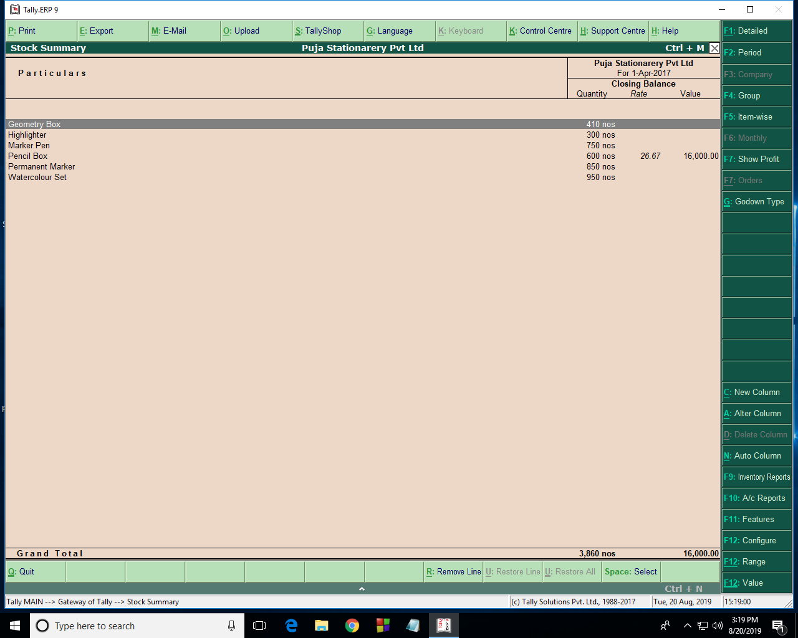

**Stock summary as on 31.05.2017**

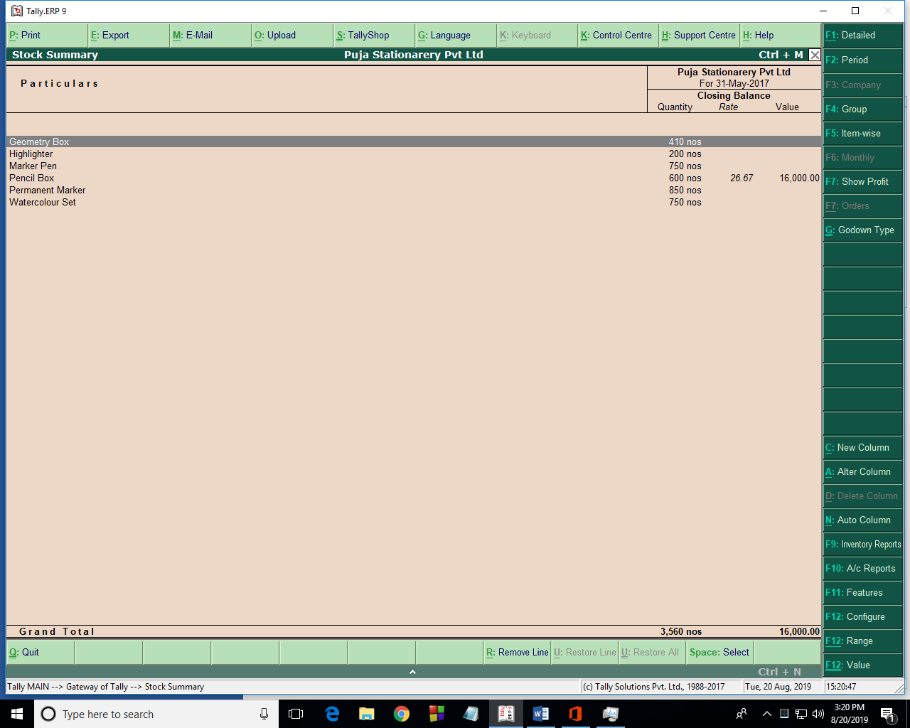

**Trial balance as on 01.04.2017**

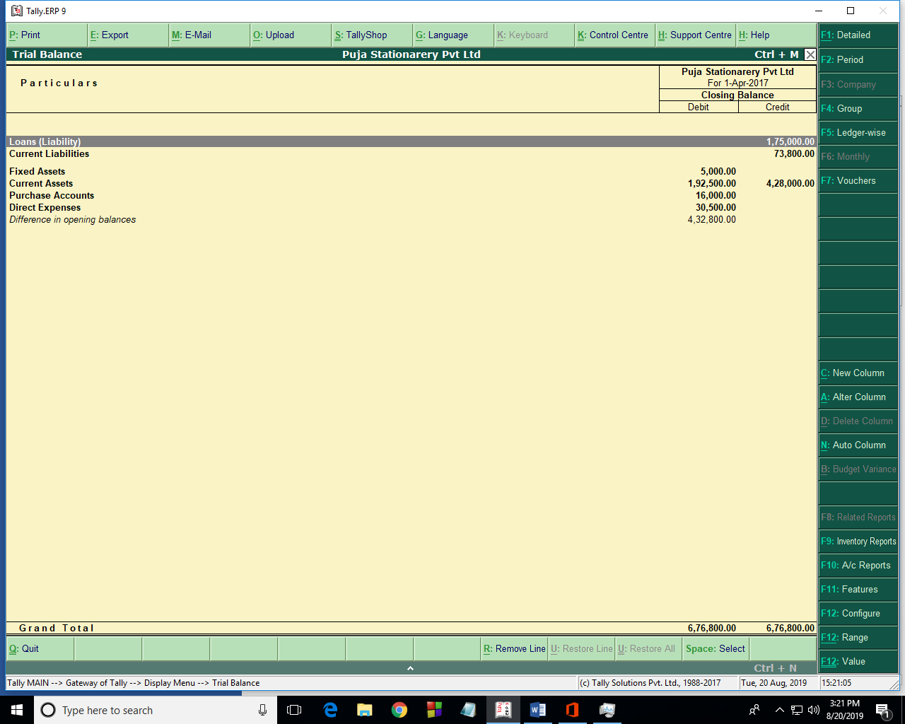

**Trial balance as on 31.05.2017**

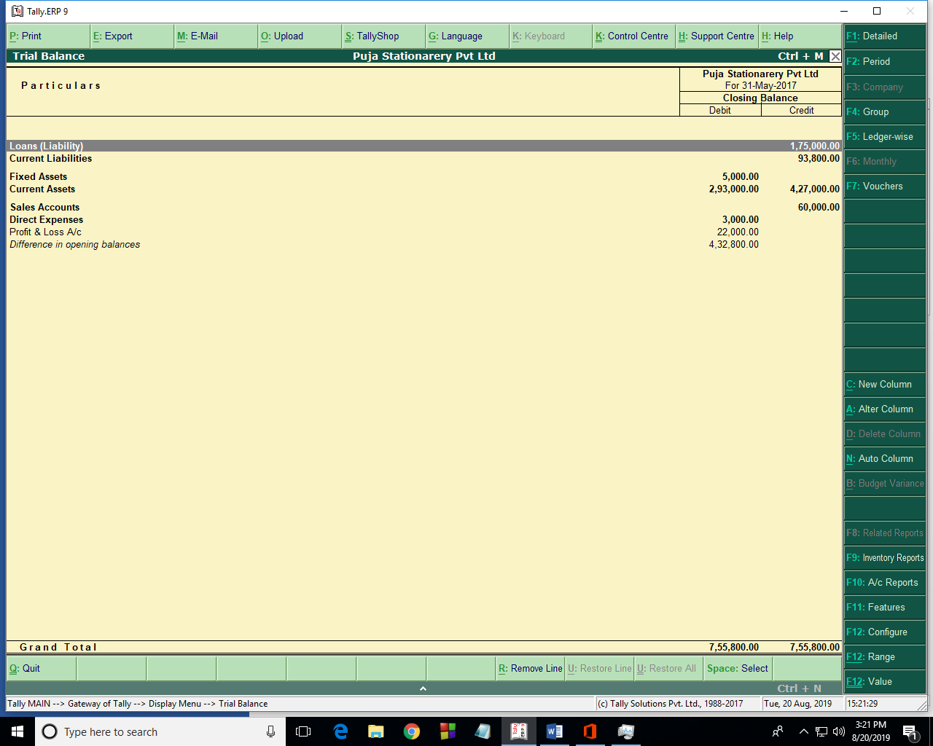

**Day book report from 01.04.2017 to 31.05.2017**

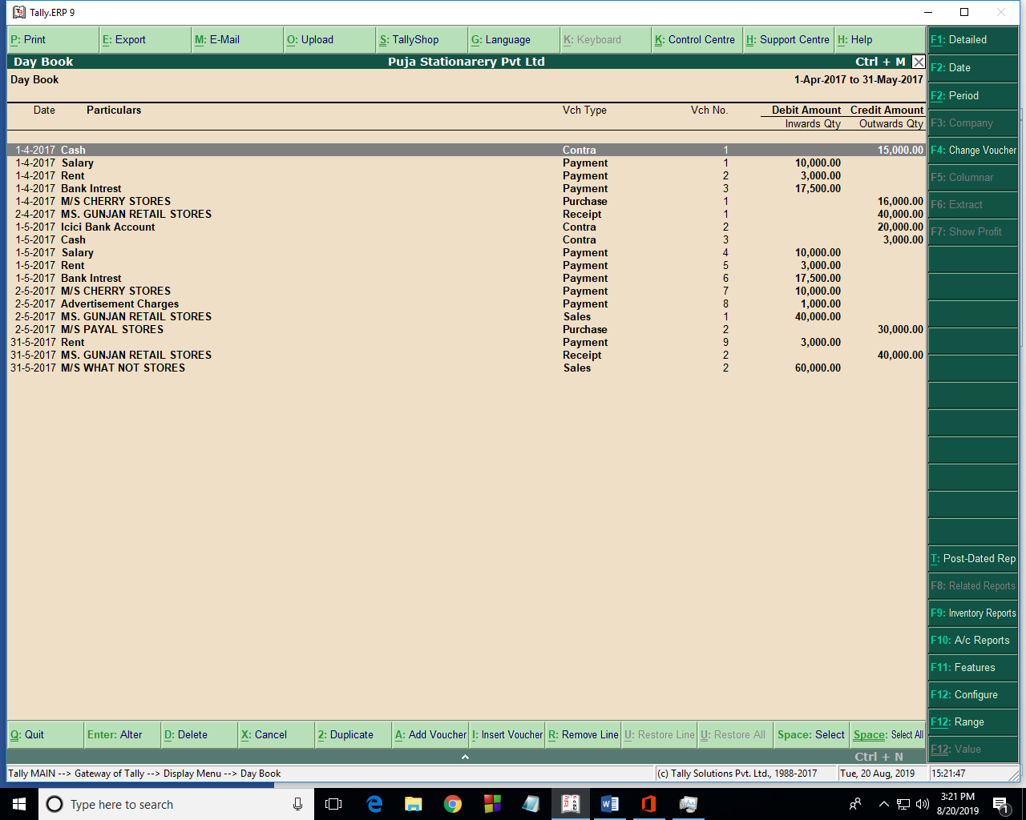

**Profit and loss a/c as on 31.05.2017**

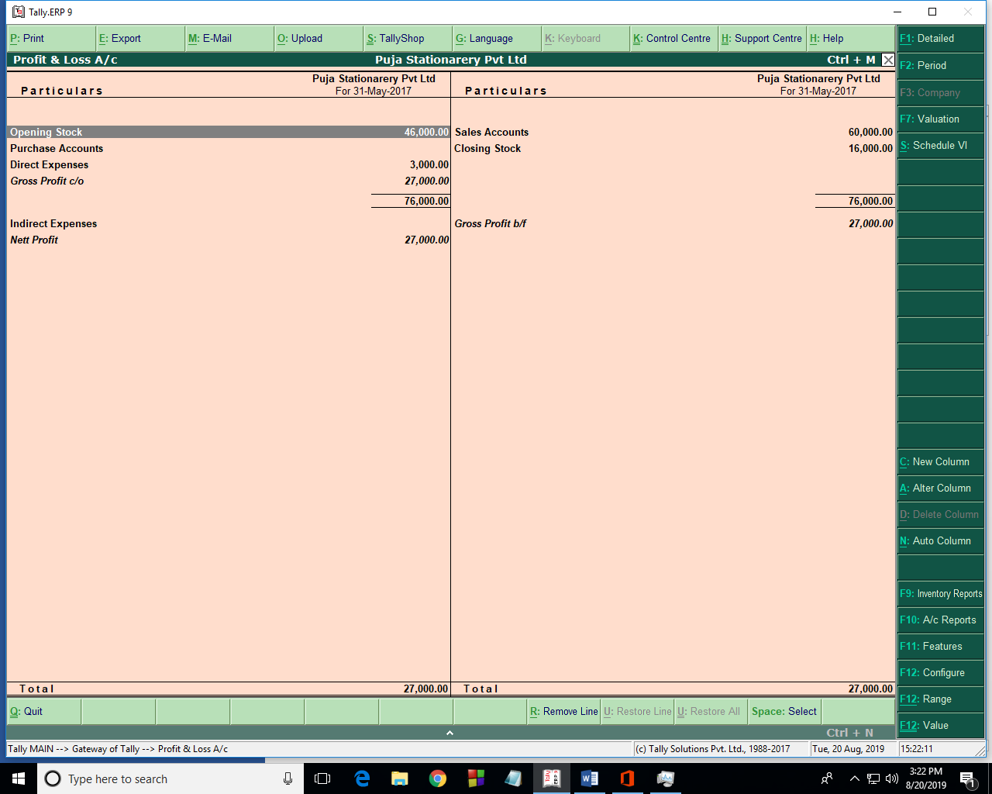

**Balance sheet as on 31.05.2017**

